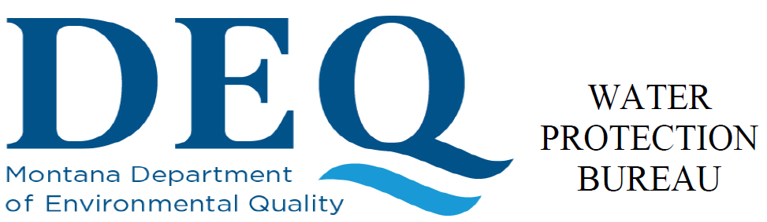 |  | Agency Use
 |  | Permit No.:
Date Rec’d
Amount Rec’d
Check No.
Rec’d By
Form  DET-SWI | Determination Worksheet  Multi-Sector General Permit for Storm Water Discharges Associated with Industrial Activity (MSGP)  MTR000000
This determination worksheet is to be completed by any facility that completes the industrial activities eligible for coverage in the MSGP, but is unsure if coverage is necessary for their site. DEQ will use best professional judgement based on the information provided to help the facility determine if coverage under the MSGP is required. This form must be completed as accurately and descriptive as possible. All determinations are subject to further review at any time.
Section A - Applicant (Owner/Operator) Information
Owner/Operator Name _____________________________________________________________________________
Mailing Address __________________________________________________________________________________
City, State, and Zip Code ___________________________________________________________________________
Phone Number _____________________________________ Email ______________________________________
Applicant contact person (name, title) _________________________________________________________________
Section B - Operation or Facility Information
Facility or Operation Name _________________________________________________________________________
Facility Contact Name _____________________________________________________________________________
Phone Number _____________________________________ Email ______________________________________
Is this an existing facility that is currently in operation Yes No
If not, what is the approximate start date of operations ____________________________________________________
Is the operation located within a recognized Indian Reservation? Yes No
Is the location in sage grouse habitat Yes No
Latitude ________________________________ Longitude ______________________________________________
Township/Range/Section (optional) ___________________________________________________________________
Physical location/directions to physical location (optional) _______________________________________________
Total size of the regulated facility or operation in acres ___________________________________________________

Section C - Industrial Activity Information
Identify Standard Industrial Activity (SIC) Codes Associated with the Facility:
Standard Industrial Classification Name |  | SIC Code
Primary
Secondary
Third
Fourth

Provide a detailed description of the nature of the facility to include activities, procedures, methods process flows, equipment and materials, and relative timeframes of activities and operations that contribute to the nature of the industrial activity at the facility:

Describe locations of anticipated stockpiles, loading/unloading areas:

Describe any other operations such as material washing, asphalt batch plant, concrete batch plant, concrete washout area, etc.:

Will the process wastewater from these operations be controlled on-site or discharged off-site?

Describe any vehicle maintenance and/or fueling that will take place at the site:

Will dewatering be necessary? Yes No If yes, where will discharge occur?

Section D – Existing or Pending Permits, Certifications, or Approvals:
None RCRA _________________________ DEQ Opencut Mining Permit #___________________
DEQ Air Quality Permit #______________________ DEQ Operating Permit #______________________
MPDES (list all) ________________________________________________________________________________
Other (list all) __________________________________________________________________________________
Section E – Storm Water Controls
Will storm water have the potential so discharge off-site Yes No

If storm water does not have the potential to discharge off-site, describe the site conditions that exist which will not allow storm water to discharge and/or describe the measures that will be implemented to control storm water on-site and keep it from discharging:

Are there state waters (see Montana Code Annotated 75-5-103(32)(a)), including streams, ditches, swales, etc. on or near the facility? Yes No

If there is no state water on or near the facility, how far is the nearest state water from the facility boundary?

Does storm water have the potential to discharge directly into state water? Yes No
Will temporary or permanent best management practices (BMPs) or control measure be implemented to control the discharge of storm water? Yes No

If yes, describe the BMPs or control measures that will be implemented (ie - berms, swales, ponds, silt fence, wattles, sediment basins, etc.):

How will storm water run-on be diverted or controlled?

Suplemental Information:
Map: Attach a topographic map of the area extending to at least one mile beyond property boundaries. The map must show the outline of the facility or operation and identify and label the location of each of its proposed outfalls. Include all surface waters, including springs and ephemeral drainages, in the map area. Identify impaired receiving waters. Delineate sage grouse habitat (if applicable).
Attach any additional applications associated with the facility such as opencut permit and/or additional MPDES permit applications
Please provide any addition supplemental information that may not have been already addressed.
Section F - CERTIFICATION
Reporting Authorization: This form must be completed, signed, and certified by an authorized signatory or duly authorized representative per Part 4.18 of the MSGP.
All Applicants Must Complete the Following Certification:

I certify under penalty of law that this document and all attachments were prepared under my direction or supervision in accordance with a system designed to assure that qualified personnel properly gather and evaluate the information submitted. Based on my inquiry of the persons who manage the system, or those persons directly responsible for gathering the information, the information submitted is, to the best of my knowledge and belief, true, accurate, and complete. I am aware that there are significant penalties for submitting false information; including the possibility of a fine and imprisonment for knowing violations. [75-5-633, MCA]

A. Name (Type or Print)

B. Title (Type or Print) |  |  | C. Phone No.
D. Signature |  |  | E. Date Signed
Return this form to:
Department of Environmental Quality
Water Protection Bureau
PO Box 200901
Helena, MT 59620-0901
(406) 444-5546
Agency Use
Based on review of the information submitted DEQ has determined the facility Does – Does Not require coverage under the MSGP.

Name____________________________________________ Date____________________________

Disclaimer: The determination has been made using best professional judgment after reviewing and evaluating the information provided. If DEQ has determined that you do not require permit coverage, this does not preclude DEQ from requiring your facility to obtain permit coverage at a later date if it is deemed necessary. This also does not preclude DEQ from seeking a formal enforcement action if the facility discharges storm water without a permit. This form does not replace a no exposure certification.

